Fat-free high-protein cheese sauce/dip

You can make a creamy, fat-free cheese sauce using homemade sodium citrate derived from baking soda and vinegar. It may not be possible to make a solid, fat-free cheese block because cheese relies on milk fat and casein proteins for its structure but this method produces a smooth sauce that stays emulsified and doesn't separate. For a fat-free sauce, simply use water as your liquid base.

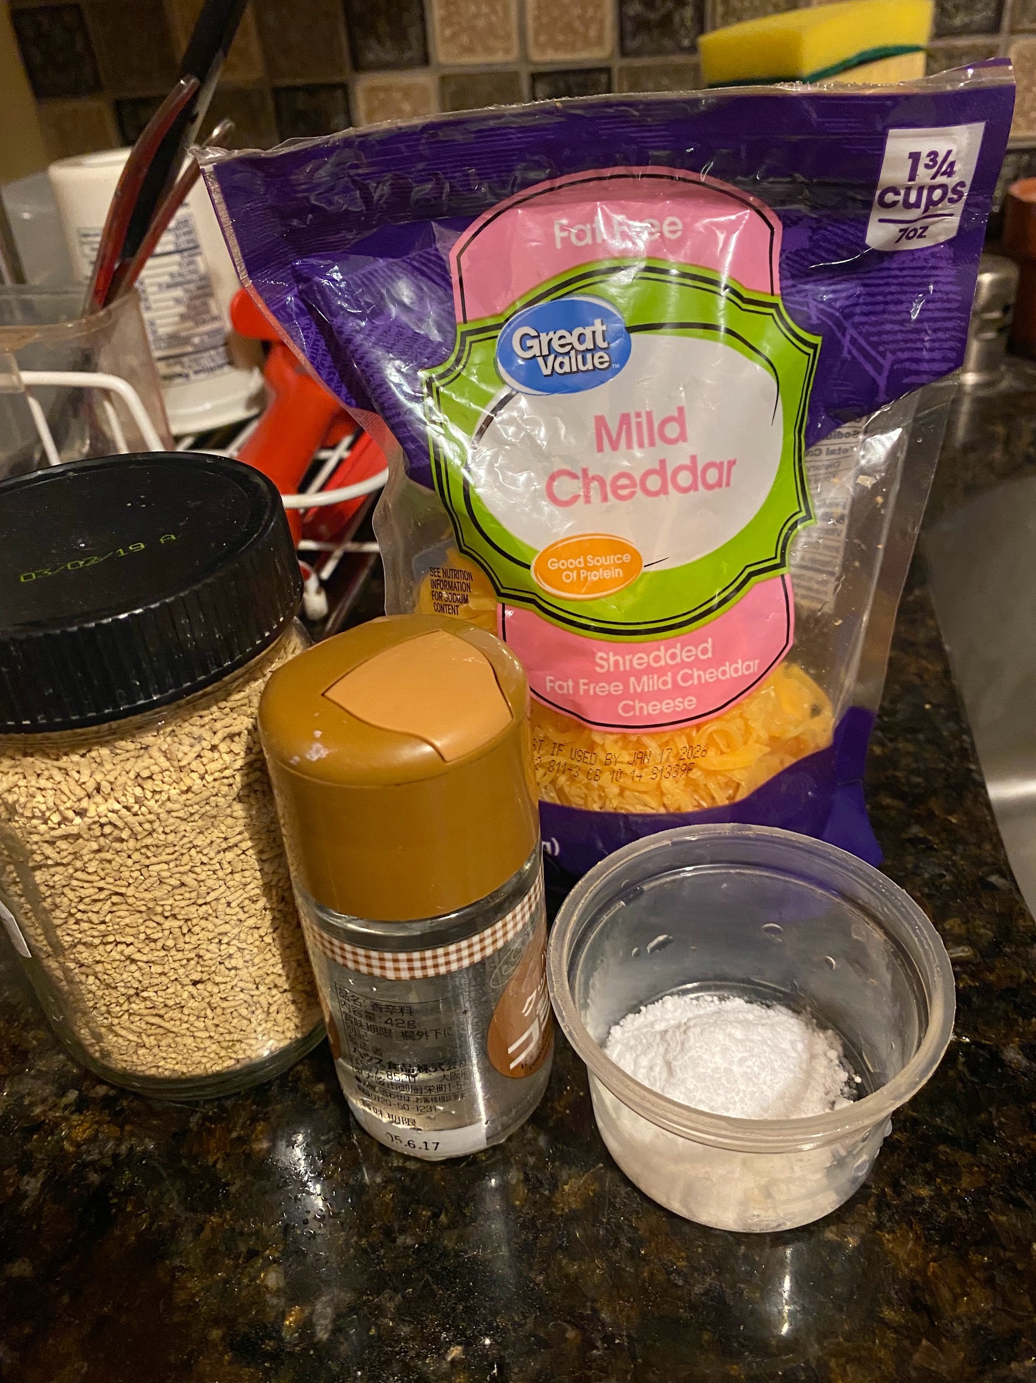

Part 1: Homemade sodium citrate
This process neutralizes the acid in the vinegar with baking soda, leaving behind a solution of sodium citrate.

Ingredients
- 1 tablespoon white distilled vinegar
- 1/4 teaspoon baking soda

Instructions
- In a small bowl, combine the vinegar and baking soda. The mixture will fizz vigorously as the reaction occurs.
- Wait for the fizzing to completely stop. This indicates that the reaction is finished, leaving you with a neutralized sodium citrate solution.

Part 2: Fat-free cheese sauce recipe
This recipe creates a rich, creamy sauce that can be used for dips, mac and "cheese," or as a topping.

Ingredients
- The homemade sodium citrate solution from Part 1
- 1 cup water
- 8 ounces shredded low-fat or fat-free cheese (e.g., low-fat cheddar, fat-free American)
- 1/2 teaspoon mustard powder (optional, for flavor)
- 1/2 teaspoon garlic powder (optional, for flavor)
- Salt and umami bombs to taste (optional, e.g. mushroom pellets)

Instructions
- Combine the 1 cup of water and the homemade sodium citrate solution in a small saucepan over medium-low heat. Stir until the sodium citrate is fully dissolved.
- Bring the liquid to a gentle simmer. Do not let it come to a rolling boil.
- Gradually whisk in the shredded fat-free cheese, a handful at a time. The emulsifying properties of the sodium citrate will prevent the cheese from clumping.
- Continue whisking constantly until all the cheese is incorporated and the sauce is smooth and creamy. An immersion blender can help achieve an extra-smooth texture.
- Stir in the optional mustard and garlic powder, and season with salt to taste.
- Serve the sauce immediately. It will thicken as it cools and can be reheated in the microwave or on the stove.

Part 3: Age and mature overnight in cold storage
This last optional step thickens the cheese sauce, making it richer and creamier. Account for this when first adding sodium citrate liquid and consider what final temperature you want to use it at since it is thermoreversible!

